We are given 3 strings: str1, str2, and str3. Str3 is said to be a shuffle of str1 and str2 if it can be formed by interleaving the characters of str1 and str2 in a way that maintains the left to right ordering of the characters from each string. For example, given str1="abc" and str2="def", str3="dabecf" is a valid shuffle since it preserves the character ordering of the two strings. So, given these 3 strings write a function that detects whether str3 is a valid shuffle of str1 and str2.

**import** java.util.*;

**public class**findShortestSubString{

**public static void** main(String[] args)

{

Scanner s = **new** Scanner(System.***in***);

System.***out***.println("Enter the String1 : ");

String str1=s.next();

System.***out***.println("Enter the String2 : ");

String str2=s.next();

System.***out***.println("Enter the String1 : ");

String str3=s.next();

**int**j=0,k=0;

**for**(**int**i=0;i<str3.length();i++)

{

**if**(j<str1.length() &&str3.charAt(i)==str1.charAt(j))

{

j++;

}

**elseif**(k<str2.length() &&str3.charAt(i)==str2.charAt(k))

{

k++;

}

**else**

{

**break**;

}

}

**if**(j==str1.length() &&k==str2.length())

{

System.***out***.println("Valid Shuffle");

}

**else**

{

System.***out***.println("Invalid Shuffle");

}

}

}

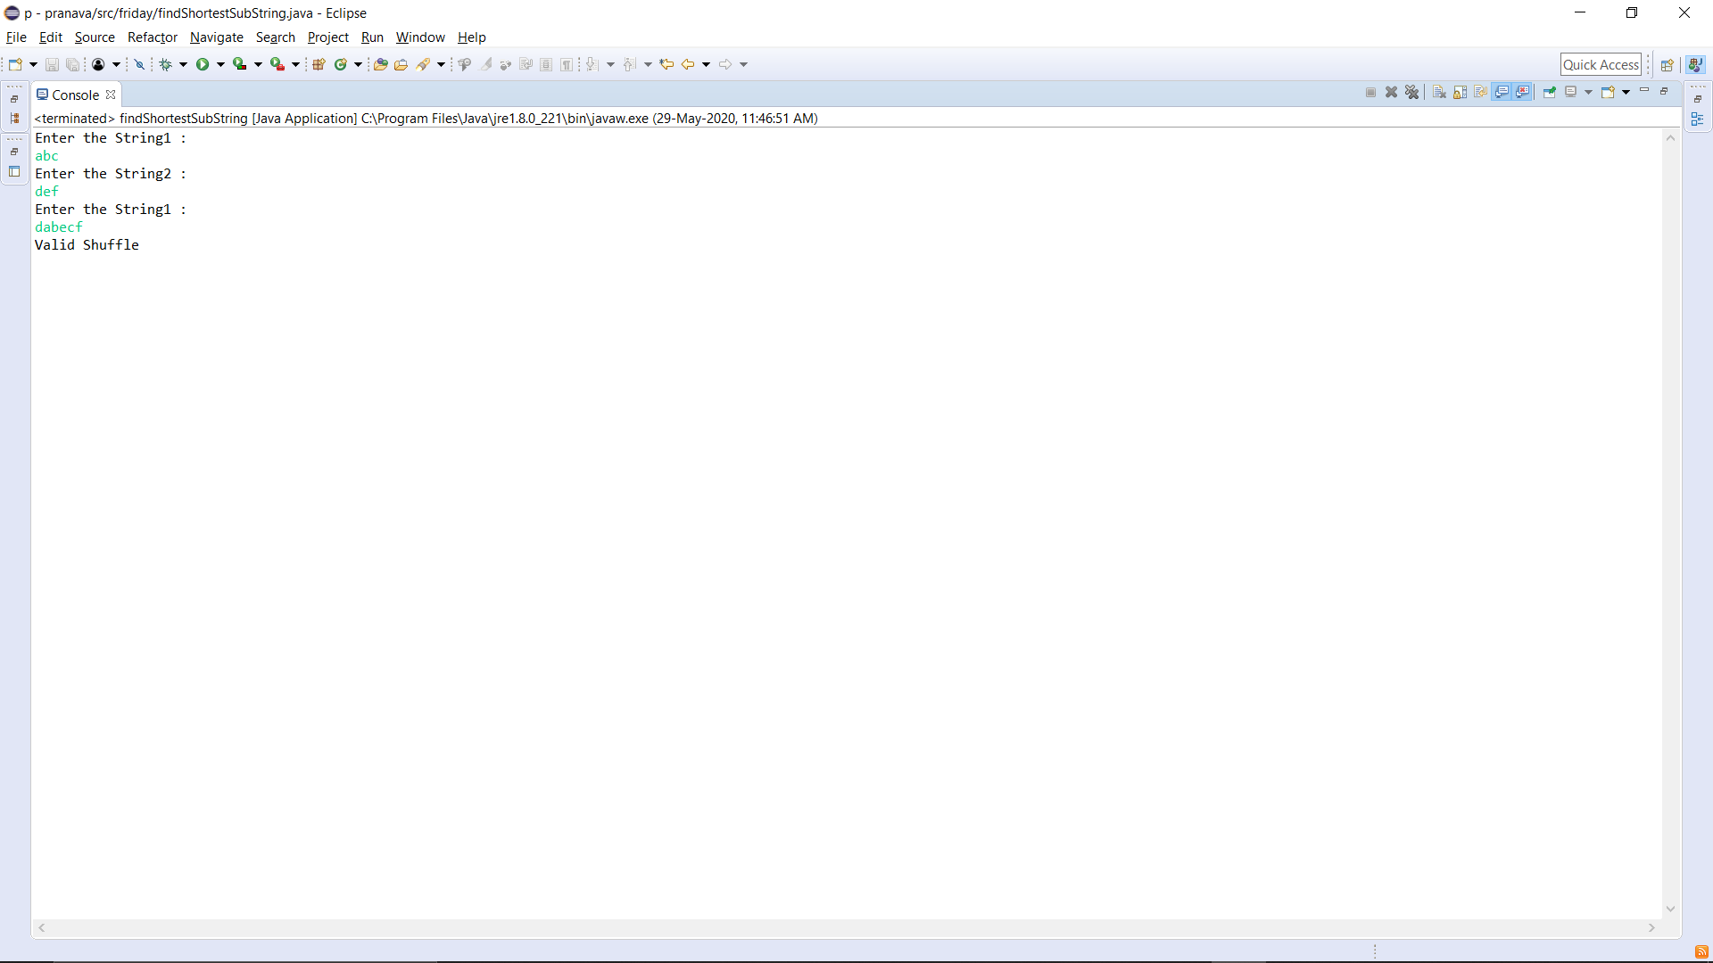**OUTPUT:**

